***Section* 4.2 – Calculus with Parametric Curves**

***Tangents* and *Areas***

A parametrized curve  and  is differentiable at *t* if *f* and *g* are differentiable at *t*.

**Parametric Formula for **

If all three derivatives exist and ,



The derivatives ,, and  are related by the Chain Rule 

**Parametric Formula for **

If the equations  ,  define *y* as a twice−differentiable function of *x*, then at any point where  and 



***Example***

Find the tangent to the curve , at the point , where 

**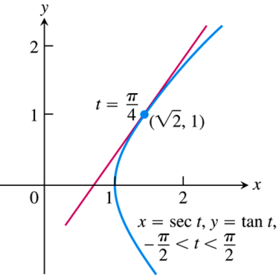*Solution***

The slope of the curve at *t* is:













The tangent line is

 





***Example***

Find  as a function of *t* if 

***Solution***





 





 







***Example***

Find the area enclosed by the asteroid: 

***Solution***

By symmetry, the enclosed area is 4 times the area beneath the curve in the first quadrant where .



 













 











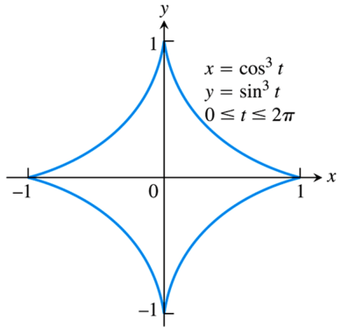

**Length of a Parametrically Defined Curve**

***Definition***

If a curve *C* is defined parametrically by  and , , where  and  are continuous and not simultaneously zero on [*a, b*], and *C* is traversed exactly once as *t* increases from  to , then the length of *C* is the definite integral



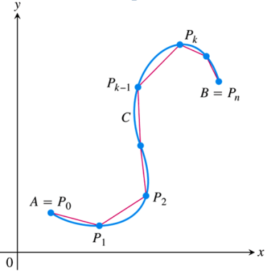 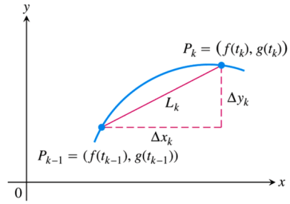

***Example***

Find the length of the circle of radius *r* defined parametrically by 

***Solution***















***Example***

Find the length of the asteroid: 

***Solution***

Because of the curve’s symmetry with respect to the coordinate axes, its length is 4 times the length of the first quadrant.











 

 



 











**Area of Surface of Revolution for Parametrized Curves**

If a smooth curve  and , , is traversed exactly once as *t* increases from *a* to *b*, then the areas of the surfaces generated by revolving the curve about the coordinate axes are as follows.

1. **Revolution about the *x*−axis (*y* ≥ 0):**



1. **Revolution about the *y***−**axis (*x* ≥ 0):**



***Example***

The standard parametrization of the circle of radius 1 centered at the point (0, 1) in the *xy*−plane is



Use the parametrization to find the area of the surface swept out by revolving the circle about the *x−*axis.

***Solution***

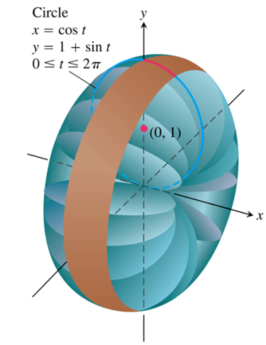















***Exercises*** ***Section* 4.2 – Calculus with Parametric Curves**

(**1 − 4**) Find all the points at which the curve has the given slope.

|  |  |
| --- | --- |
|  |  |

(**5 − 12**) Find an equation of the line tangent to the curve at the point corresponding to the given value of *t*.

|  |  |
| --- | --- |
|  |  |

(**13 − 33**) Find the tangent to the curve at the point defined by the given value of *t*. Also find the value of  at this point

|  |  |
| --- | --- |
|  |  |

(**33 − 37**) Find the equations of the tangent lines at the point where the curve crosses itself

|  |  |
| --- | --- |
|  |  |

(**38 − 40**) Find the slope of the curve  at the given value of *t*. Define *x* and *y* as differentiable functions.

1. 
2. 
3. 

(**41 − 37**) Find 

|  |  |
| --- | --- |
|  |  |

1. Find an equation of the line tangent to cycloid  at the points corresponding to  and .
2. Consider Lissajous curve, estimate the coordinates of the points on the curve at which there is





1. A horizontal tangent line
2. A vertical tangent line.
3. Consider Lissajous curve, estimate the coordinates of the points on the curve at which there is





1. A horizontal tangent line
2. A vertical tangent line.

(**48 − 58**) Find the area of the region

1. 

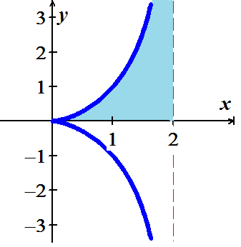

1. 

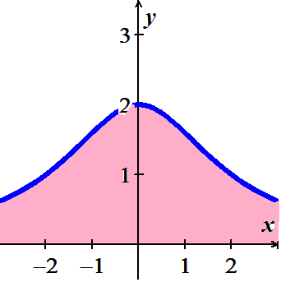

1. Find the area under one arch of the cycloid 
2. Find the area enclosed by the *y*−axis and the curve 
3. Find the area enclosed by the ellipse 

|  |  |
| --- | --- |
|  |  |
|  |  |
|  |  |
|  |  |
|  |  |
|  |  |

(**59 − 68**) Find the lengths of the curves

1. 
2. 
3. 
4. 
5. Hypocycloid perimeter curve: 
6. Circle circumference: 
7. Cycloid arch: 
8. Involute of a circle: 
9. 
10. 

(**69 − 80**) Find the areas of the surfaces generated by revolving the curves

1. 
2. 
3. 
4. 
5. 
6. 
7. 
8. 
9. 
10. 

|  |  |
| --- | --- |
|  |  |

1. 

|  |  |
| --- | --- |
|  |  |

1. 

|  |  |
| --- | --- |
|  |  |

1. Use the parametric equations  to
2. Graph the curve on the interval .
3. Find  and 
4. Find the equation of the tangent line at the point 
5. Find the length of the curve
6. Find the surface area generated by revolving the curve about the 
7. Use the parametric equations 
8. Find  and 
9. Find the equation of the tangent line at the point where 
10. Find all points (if any) of horizontal tangency.
11. Determine where the curve is concave upward or concave downward.
12. Find the length of one arc of the curve
13. The involute of a circle is described by the endpoint *P* of a string that is held taut as it is unwound from a spool that does not turn.

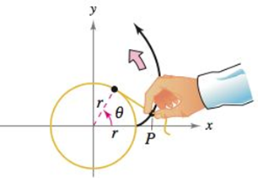

Show that a parametric representation of the involute is



1. The figure shows a piece of string tied to a circle with a radius of *one* unit. The string is just long enough to reach the opposite side if the circle.



Find the area that is covered when the string is unwounded counterclockwise.

1. An Air traffic controller spots two planes at the same altitude flying toward each other.

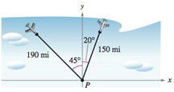

Their flight paths are 20° and 315°. One plane is 150 *miles* from point *P* with a speed of 375 *miles per hour*. The other is 190 *miles* from point *P* with a speed of 450 *miles per hour*.

1. Find parameteric equations for the path of each plane where *t* is the time in *hours*, with  corresponding to the time at which the air traffic controller spots the planes.
2. Use part (*a*) to write the distance between the planes as a function of *t*.
3. Graph the function in part (*b*).
4. When the distance between the planes be minimum?
5. If the planes must keep a separation of at least 3 *miles*, is the requirement met?